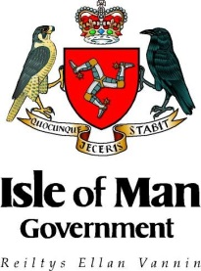
INTERNATIONAL DEVELOPMENT PARTNERSHIPS FUNDING
Safeguarding Template

Project title
Applicant organisation(s)
Location
Identified Persons at Risks | Steps Taken | Risk Owner | Procedure for Reporting/ Dealing with Misconduct
e.g. vulnerable adults due to financial circumstances, disability etc. persons under 18 years of age. | What steps have been taken, or will be taken during the project, to minimise the risk? | Who is responsible for preventing/  managing this risk? | What procedures are in place to report or deal with allegations of Misconduct?

