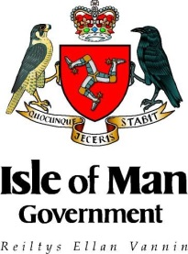
INTERNATIONAL DEVELOPMENT – SMALL GRANT FUNDING
Risk Assessment Template

Project title
Applicant organisation(s)
Location
Identified Risks | Potential impact on project | Severity | Probability | Steps Taken | Risk Owner  (Name and Role)
 | How would this impact on the project’s ability to carry out its activities and meet its objectives? | How severe would the impact be? (high/medium/low) | How likely is this to occur? (high/medium/low) | What steps have been taken, or will be taken during the project, to minimise the risk? | Who is responsible for preventing/  managing this risk?
Risks associated with the target region
e.g. political instability, draught, geographical location, transport links
Operational Risks
e.g. delays in procurement, change in project scope, failure by partner organisations, ‘on-the-ground’ risks
Financial Risks
e.g. fluctuations in currency exchange rates, delays in receipt of funding from partner agencies, risks in the transfer of funds from the Isle of Man to project location, cash handling
External Risks
e.g. political situation in the region, potential impact of events such as poor weather, natural disasters, outbreak of disease
Compliance with laws and regulations
e.g. awareness of sanctions in target country, legal authority to work in the country, etc
Safeguarding risks (if appropriate)
e.g. potential risks identified to children in respect of project activities, risks to vulnerable persons participating in the project, etc
Organisation risk
e.g. Within the organisation such as staff reputation, capacity and internal procedures
Other

