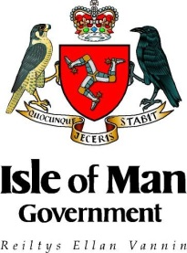
INTERNATIONAL DEVELOPMENT – SMALL GRANT FUNDING
Communications Plan Template

Project title
Applicant organisation(s)
Location
Communications Activity and Channel | Key Message | Objective | Target Audience and Reach | Timeframe | External Considerations | Monitoring and evaluation
List the activities that will promote and raise awareness of the project and Isle of Man Government funding on the Isle of Man (e.g. press release, radio interview, public talk) Links to Isle of Man initiatives. | What will be the message that is communicated? | What will this communication achieve? Why will this method be effective? | Details of target audience (primary and secondary) and how many people will this reach? | When will this take place? (e.g. before project, at a point during the project, after project) | Are there any legal or ethical considerations to manage? | What does success and meeting the objective look like? How will you evaluate this?
- On the Isle of Man (e.g. press release, radio interview, public presentation)
<Insert new rows as required>
- In project country (e.g. plaque, sign or flag at project location, engagement with local media)
<Insert new rows as required>
- Other
<Insert new rows as required>

