Form ID1(b)
Application Number (LR use only)

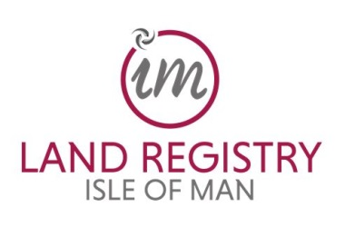
LODGING ADVOCATE’S CERTIFICATE (COMPANIES)
Please see ‘Guidance Notes for Advocates ID Forms’ before completing this form.

To be completed by any Advocate who is representing a party to the transaction
being registered and who is submitting the application to the Land Registry

CERTIFICATE
I certify that I have undertaken the necessary checks and enquiries to establish the identity of the parties on whose behalf I have acted in this transaction as listed below.
Where I have acted for the legal owner of the estate the subject of the transaction I have confirmed the identity of any third party with a beneficial ownership in the estate, as at the date of the transaction (or in the case of voluntary registration at the date of the application), in conformity with the Proceeds of Crime Act 2008 and the Anti-money Laundering and Countering the Financing of Terrorism Code 2019.

Signed
Print full name of Advocate
Date

DETAILS OF COMPANY
Name of Company
Isle of Man Registered Company Number
Capacity of company (vendor, purchaser etc)

DETAILS OF SIGNATORIES
To be completed for persons signing on behalf of the company represented by the advocate named above in the transaction being registered
Full name | Residential address
 | Postcode:
Capacity (director, secretary etc)
Date of Birth

Full name | Residential address
 | Postcode:
Capacity (director, secretary etc)
Date of Birth

Full name | Residential address
 | Postcode:
Capacity (director, secretary etc)
Date of Birth

Full name | Residential address
 | Postcode:
Capacity (director, secretary etc)
Date of Birth

Full name | Residential address
 | Postcode:
Capacity (director, secretary etc)
Date of Birth

Full name | Residential address
 | Postcode:
Capacity (director, secretary etc)
Date of Birth

Full name | Residential address
 | Postcode:
Capacity (director, secretary etc)
Date of Birth

Use additional pages if necessary – please score through unused sections.

